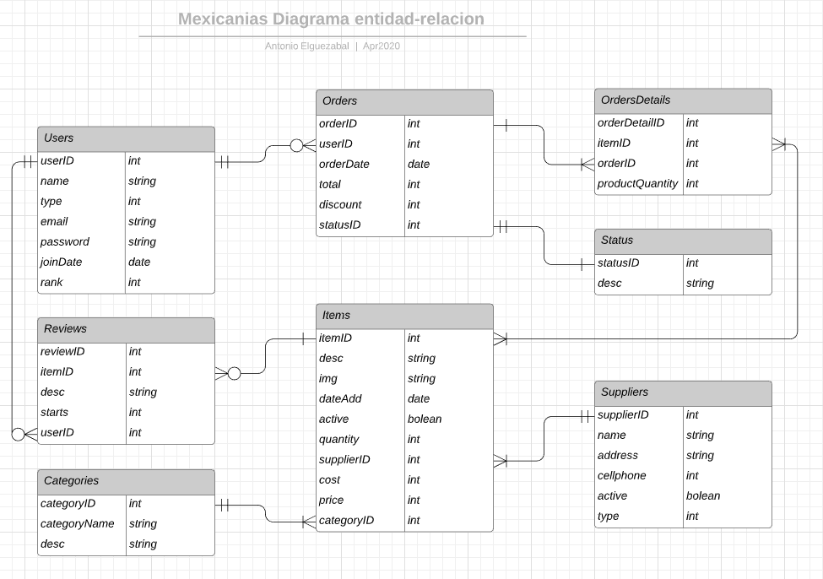

<https://www.lucidchart.com/documents/edit/96ade196-9983-4bdc-b772-42b2ec8baef6/0_0?beaconFlowId=1D91D8D5C6431429#?folder_id=home&browser=icon>